Case Study Unit 10

Chulwalar Export Forecast

**Introduction**

The purpose of this analysis is to test a variety of forecasting methods for predicting the exports of island of Chulwalar, part of the island group Urbano. The data available are the past exports of flowers ranging from the years 2008 to 2013, planned exports from 2008 to 2013 for spices and teas, and a number of indicators likely related to exports (satisfaction indexes, export prices, temperature, etc). In addition, there are also a number of national holidays in March, April, and December which influence exports.

**Methodology**

The software used to perform the forecasts is RStudio utilizing the “fpp” and “forecast” packages. These packages allow the use of the below forecasting methods.

* Simple Exponential Smoothing
* Holt’s with Linear Trend
* Holt’s with Exponential Trend
* Holt’s with Exponential Trend and Dampening
* Holt’s with Linear Trend and Dampening
* Holt’s Winter’s (HW) with Additive Seasonality
* Holt’s Winter’s (HW) with Multiplicative Seasonality

**Model Selection and Performance Criteria in context of Chulwalar Data Set**

Generally, the Holt-Winters exponential smoothing is used when the data exhibits both trend and seasonality. The two main HW models are Additive model for time series exhibiting additive seasonality and Multiplicative model for time series exhibiting Multiplicative seasonality. We analyze our data for “Trend” and specific type of “Seasonality” to determine application of model type. We then compare the performance / accuracy of forecast metrics of each model to base our final recommendations.

***Trend***

If the values of the parameters *β*0 and *β*1 are slowly changing over time, Holt’s trend corrected exponential smoothing method can be applied to the time series observations. Our dataset exhibits a rising trend for the period 2008 – 2013 with a *β*0 [alpha] of 0.671 and *β*1 [beta] changing over time. This by definition illustrates a trending time series.

***Seasonality***

The term “Seasonality” is defined as a cyclical or repeating pattern over a fixed time or interval. The intervals could be daily, weekly or annual and is identified at data collection stage as well as through testing the data. Main techniques used for this purpose are Seasonal Indexing or Trigonometric Functions.

The distinction between Additive and Multiplicative seasonality is the way in which daily, weekly and annual patterns impact data points in the series. The additive seasonal model is therefore appropriate for a time series in which the amplitude of the seasonal pattern is independent of the average level of the series, i.e. a time series displaying additive seasonality and therefore “the amount of seasonality adjustment is constant for all levels (average value) of the series”**1**. On the other hand, the multiplicative seasonality is identified if “the amount of adjustment varies with the level of the series”**2**.

In our case, the data exhibits a multiplicative seasonality. This can be identified by the fact that products under review are perishable / seasonal and that the production is seasonal as well as the sales are tied to the festive season in December of each year. The quantitative manifestation of multiplicative seasonality is described by the metrics presented in an included table

**Overview and Rationale of Data Cleansing**

The key limitations of HW method are:

Unusual values or Outliers: Left unattended, outliers can distort HW forecasts.

Prevalence of multiple seasonal cycles, such as a combination of day-of-week patterns and month-of-year patterns. Traditional HW could account for only a single seasonal pattern.

Initially the raw data was loaded into R Studio as Data Frames. In order to perform the forecast, the data had to be transformed into Time Series. Analysis of the time series was then performed to check for outliers and/or missing data.

After that, correlations for actuals and planned were performed. As can be seen below, there are high correlations amongst various flowers and exports, indicating they will be good predictors of exports.



A linear model was then created for total actual flower production vs total planned exports. The linear model was found to be a good fit since the R-squared = 0.8433 and the p-value was < 2.2e-16.

Next the STL function was used to assess linearity and seasonality of exports. The trend of total exports was found to be almost linear with uniform seasonality, as shown below.

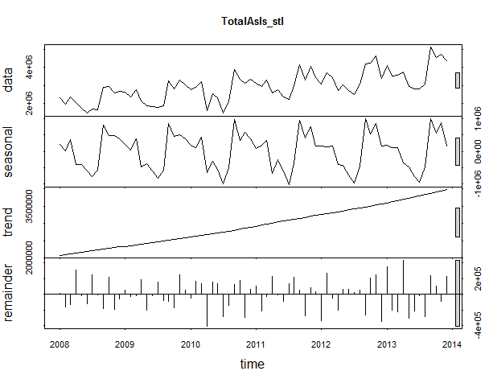

Individually however, less linearity was seen. Efak, Wuge, Red Etel, and Total Etel were found to have S like linearity as shown below.

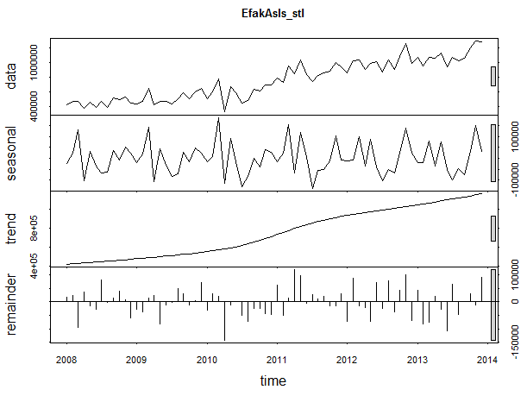

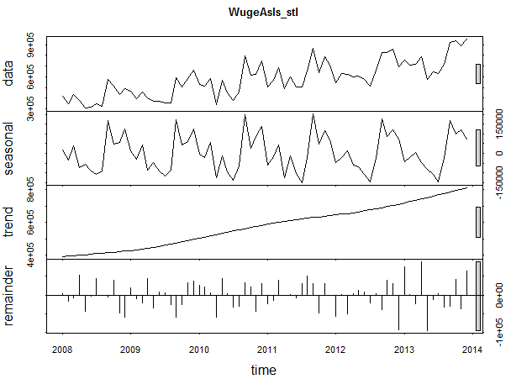

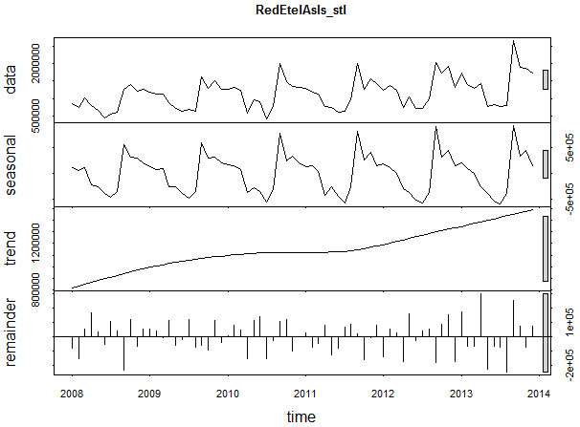

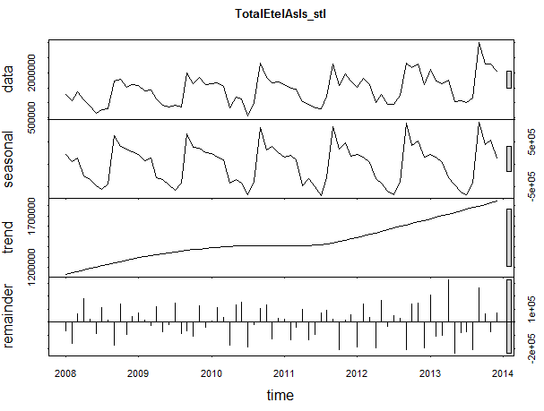

Blue Etel however, showed a U shaped trend.

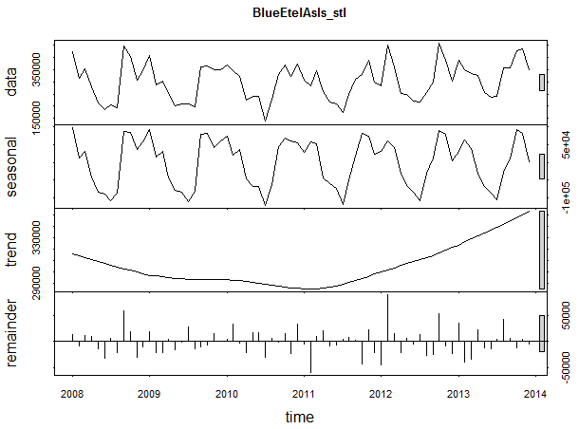

The next step was to assess the correlation of the provided indicators vs total exports. A table of the correlations is shown below.



From this, we observe the top 3 predicators of exports to be:

* Change in Export Price Index
* Urbano Total Exports
* Globalization Party Membership.

Next various forecasting models were assessed which include the bulleted below. Below are graphs of the different forecast methods.

* Simple Exponential Smoothing
* Holt’s Linear
* Holt’s Exponential
* Damped Holt’s Linear
* Damped Holt’s Exponential
* Holt-Winters’ Additive Seasonal
* Holt-Winters’ Multiplicative Seasonal

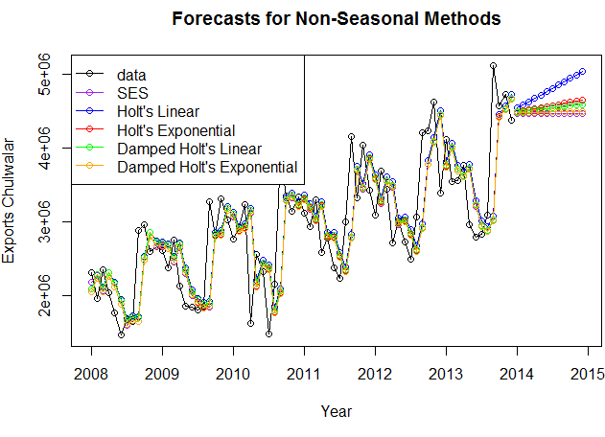

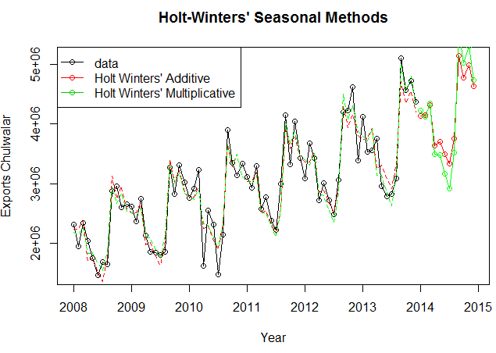

As shown above, the non-seasonal methods predict only straight lines and give no predictions for seasonality while the seasonality methods predict monthly variations. However, to choose the best method, a number of accuracy measurements were assessed for each method. These measures are outlined in the table below.



As shown above, the seasonal methods are more accurate by most measures. The additive seasonal method was better for AIC, AICc, BIC, and MPE while the multiplicative method was better for RMSE, MAE, MAPE, and MASE.

**Summary**

After performing the analysis, the Holt-Winter’s multiplicative seasonal method was found to be best suited for predicting Chulwalar’s exports. While the additive seasonal method is more accurate by some measurements, preference is given to error measurements, which the multiplicative seasonal method was found to be more accurate for. Advice to the Prime Minister of Chulwalar would be to use that method as guidance when planning exports.

**Follow up Analysis**

One year later, actuals were assessed against predictions of the Holt’s Winter’s additive and multiplicative seasonal methods. MAPE values were calculated and are show in the table below.



As can be seen, the additive seasonality method resulted in a MAPE for 2014 of 10.8% while the multiplicative method resulted in a MAPE of 15.7%. In hind sight, the additive model would’ve resulted in a more accurate forecast.